**Jenkins Task 1 Date:26-08-2024**

**1) Install jenkins and run jenkins on port number 8081.**

To install Jenkins we need To install java

* sudo apt update
* sudo apt install fontconfig openjdk-17-jre
* java -version

To install Jenkins move to official site and copy the commands as below

* sudo wget -O /usr/share/keyrings/jenkins-keyring.asc \
* https://pkg.jenkins.io/debian/jenkins.io-2023.key
* echo "deb [signed-by=/usr/share/keyrings/jenkins-keyring.asc]" \
* https://pkg.jenkins.io/debian binary/ | sudo tee \
* /etc/apt/sources.list.d/jenkins.list > /dev/null
* sudo apt-get update
* sudo apt-get install Jenkins

To change the default port number we need to enter below file and change the port number

* /lib/systemd/system/jenkins.service

After changing the port number reload the server using

* systemctl daemon-reload
* systemctl start Jenkins

then we can see the port number has been changed

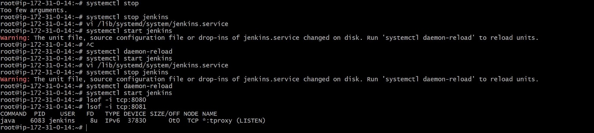

**2) Secure Jenkins server**



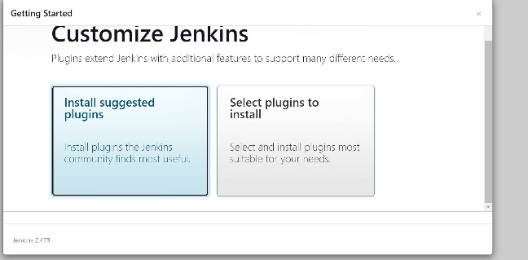

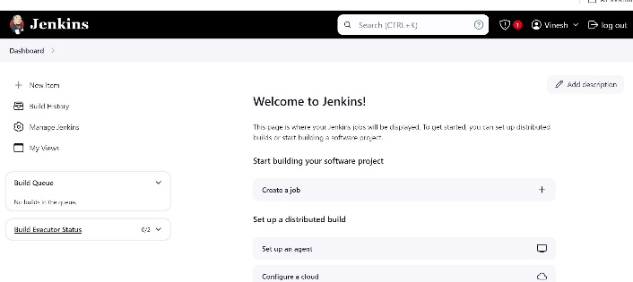

**3) Create users called Devops, Testing in Jenkins with Limited access.**

**To create users**

* **Dashboard 🡪Manage Jenkins 🡪 users**

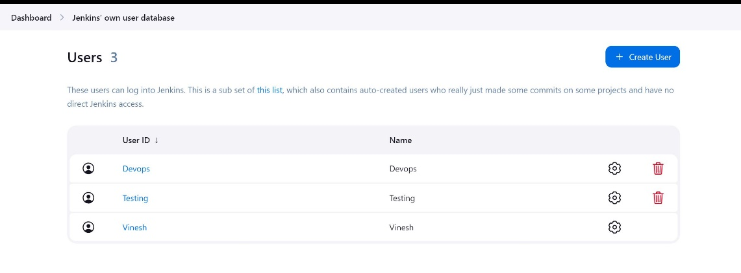

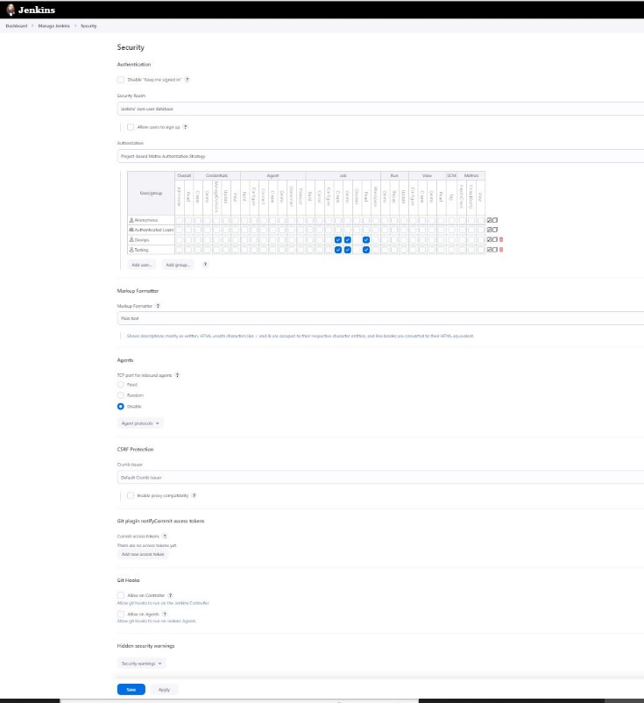

**4) Configure labels and restrict the jobs to execute based on label only.**

To create label dashboard 🡪 managejenkins 🡪 system 🡪

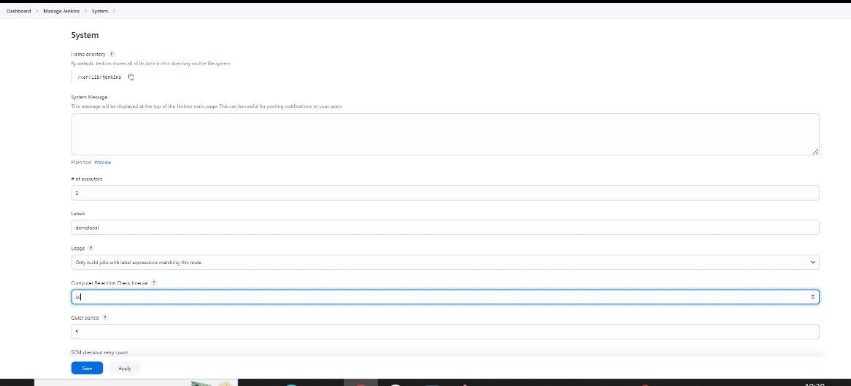

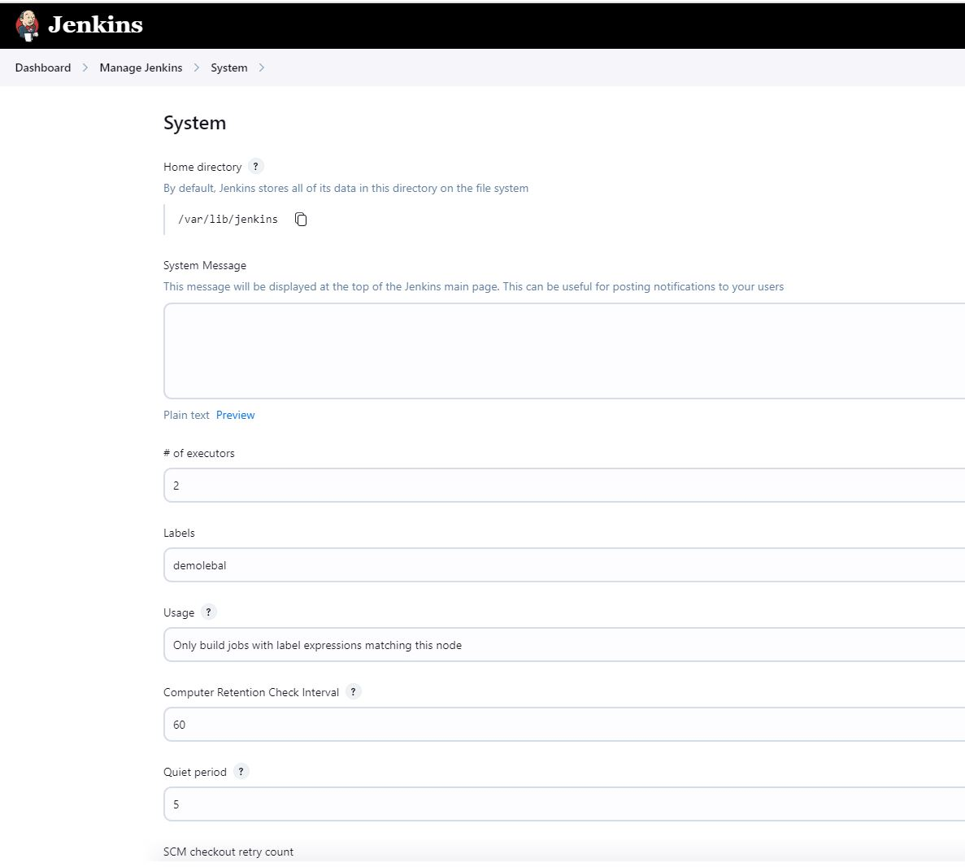

Attach the created label to the Job

Dashboard 🡪 manage Jenkins 🡪 jobname 🡪 configure 🡪 add label to the job



**5) Create Three sample jobs using the below URL.** [**https://github.com/betawins/Techie_horizon_Login_app.git**](https://github.com/betawins/Techie_horizon_Login_app.git)

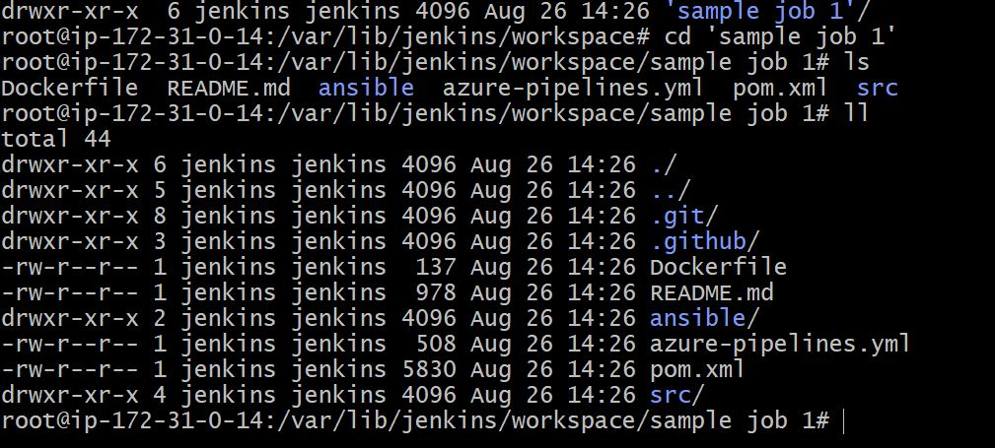

**6) Create one jenkins job using git hub Private repository.**

To create a job using private repository

* Copy the http of the repo
* Now create a token in github to create and select repo while creating the token and generate the token
* Now add the username and insert the token as password
* And then create a job

